Bad charts

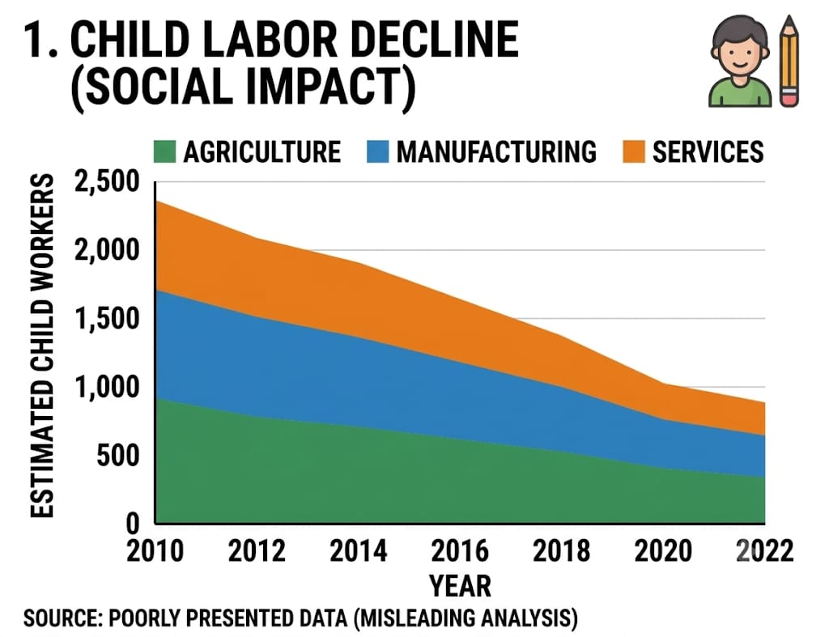

Stacked Area Chart: Bad because overlapping areas distort category comparisons over time, colors lack sufficient contrast.

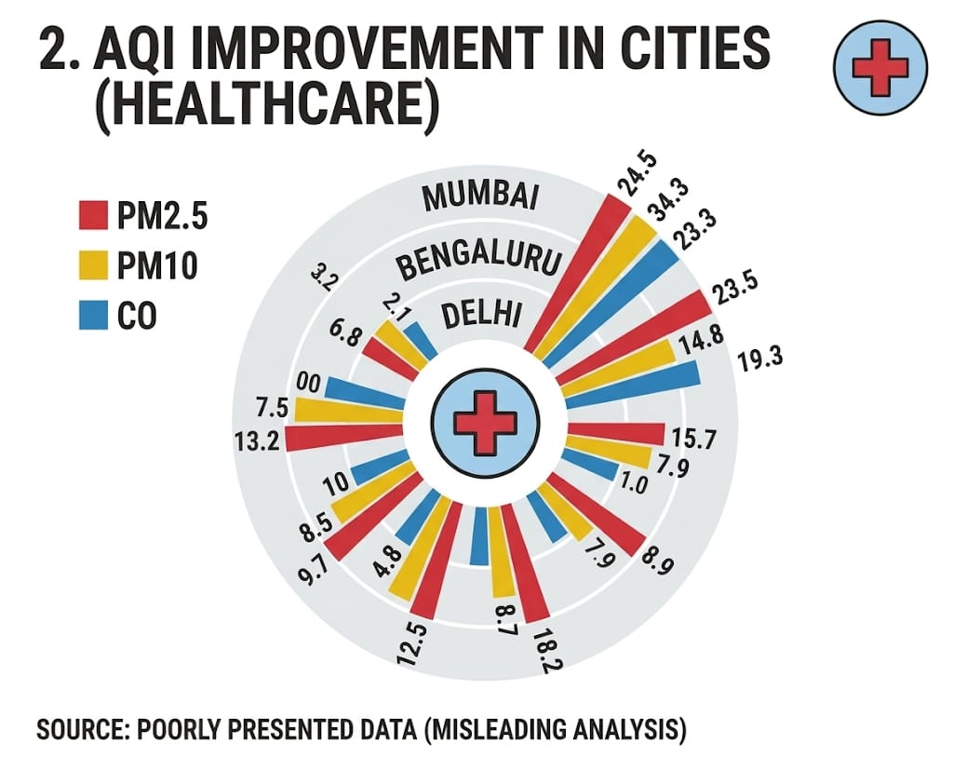

Radial/Polar Chart: Bad because circular encoding makes values difficult to compare accurately; colors are cluttered and distracting.

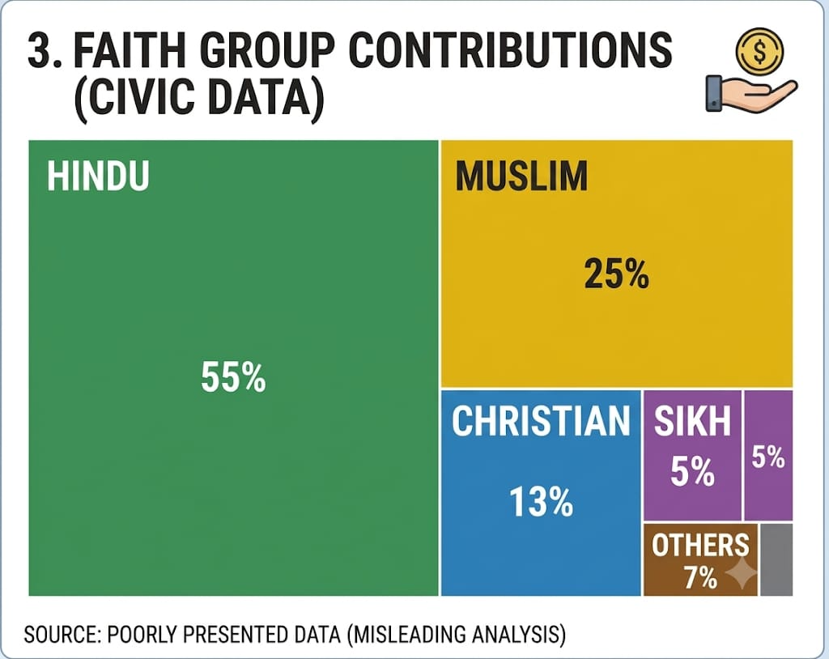

Treemap: Bad because people struggle to compare areas precisely; colors imply importance without meaning.

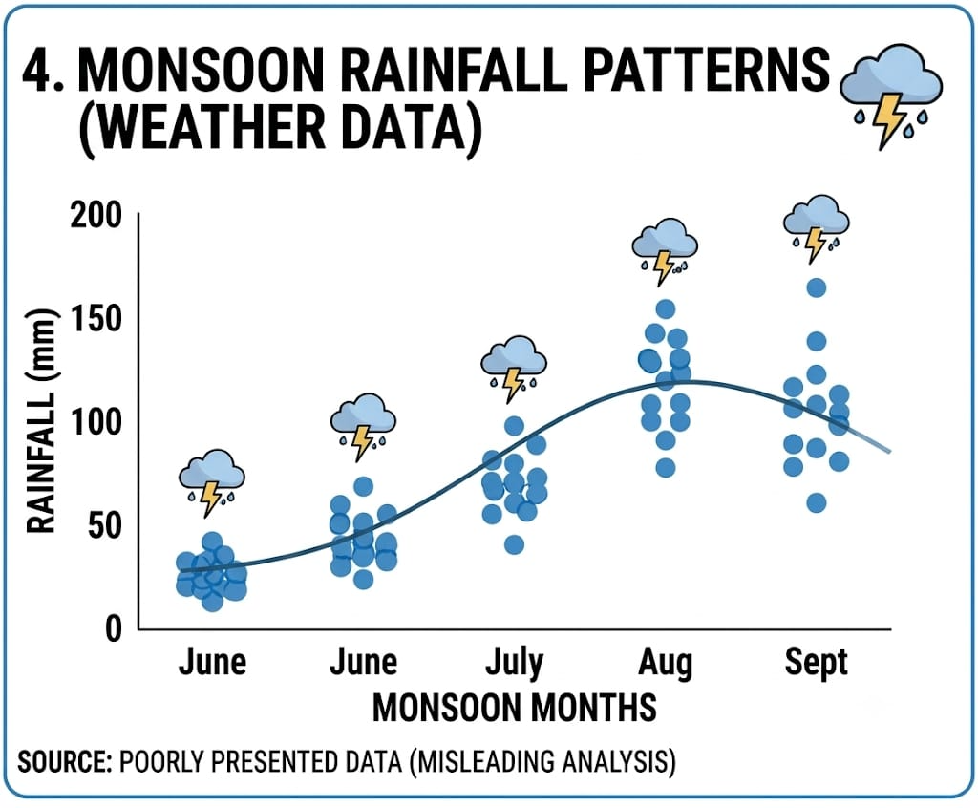

4.Scatter Plot with Trend Line: Bad because decorative weather icons create unnecessary visual clutter; colors are acceptable but secondary elements distract.

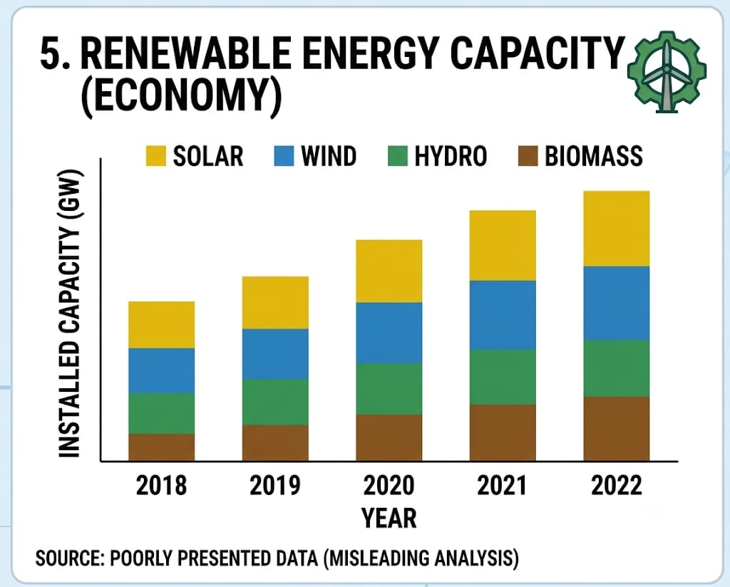

Stacked Bar Chart: Bad because individual category trends are hard to compare across years; colors are not very colorblind-friendly.

